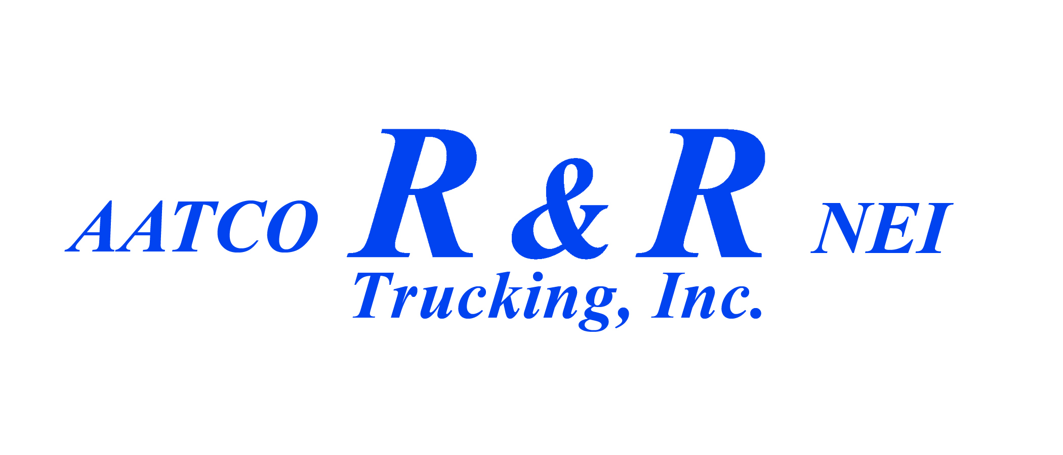
Plattsburgh Terminal trailer drop procedures:

Trailer empty, good condition and clean – drop in empty yard - The trailers in the empty yard will be inspected daily by Plattsburgh terminal personnel. The trailers that pass inspection will be green tagged. Those trailers that do not pass inspection will be red tagged. Please use only "green-tagged" empty trailers for loading.

Loaded trailers in good condition – Drop in Safe Haven if required; non-safe haven loads drop in front of terminal.

Trailers needing repair:
Empty trailer drop in front of terminal with Red Tag; note what is wrong and truck number on the red tag.

Loaded trailer with safe haven load place in Safe Haven; put a paper with the bills explaining issue and call Duenweg Terminal and have them notify Ken by e-mail of the issue.

Loaded trailer with non-safe haven load place in front of the terminal; put a paper with the bills explaining issue and call Duenweg Terminal and have them notify Ken by e-mail of the issue.

