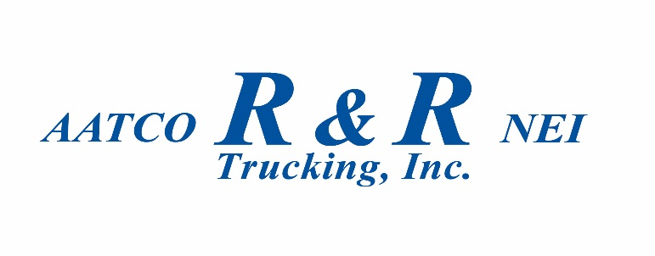
Milan TN Location

R&R equipment can only be dropped or picked up inside the Milan base. DO NOT drop empty equipment at the gate.
Any equipment exchange must be coordinated by calling Security @ 731-686-6101.
Safe Haven of freight can be arranged at our terminal area by contacting your driver manager during regular business hours; upon approval by David Shull.

